**Model A – Name and Surnames:**

Given a database name “mobile”, do the following SQL database managements and queries. Having the same result in the query does not guarantee a total correctnes of the query.

1. Modify the database according to the following instructions. [1.5 points]

* Create the table “country” according to the entity-relationship model, and choose a proper type and size for each attribute.
* Change the name of the attribute ‘name’ to ‘countryname’.
* Modify the table and add the attribute “numberoffices” to store the number of offices in the country.
* Modify the table to check up that the number of offices has to be a positive number, below 100.
* Remove the attribute “numberoffices”.
* ‘Oppo’ and ‘Fairphone’ are manufactured in ‘Dongguan’ and ‘Netherlands’respectively. Insert those values in the table country where students have to choose the value for the attribute ‘id’.
* Display the name of those mobiles and the country where they are manufactured, if they have country or not.

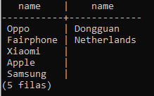

1. Display only once the name of those components which do not have ‘magnesium’ or ‘nickel’ in ascending order (join, in). [1.5 points]

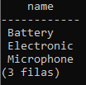

1. Display the name of those components made of at least one material where the first letter is ‘g’. [1.5 points]

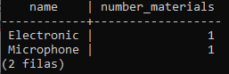

1. Display the name of those materials with a known origin except those from ‘Argentina’ [1.5 points]

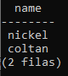

1. Display those materials which come from two locations and those with unknown origin. [2 points]

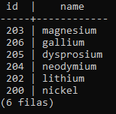

1. Display the id and name of those mobiles with a number of components higher than all mobiles with a number of four components, and display also the number of components.

[2 points]

